 | WORK ORDER
Roosevelt Ridge | W.O. # 20180615  Date: June 15, 2018
from | Ted Bertele  HOA Director  Project Manager  303 618 8200  TBERTELE@MSN.COM | iNVOICING | Karen Burback  12434 W 85th Ave  Arvada CO 80005  303-929-2229  KABPS@MSN.COM
To | Steve  Black Diamond Excavating  20 Venus Road  Black Hawk CO 80422  (303) 601-4216  blackdiamondexcavation@gmail.com | Job | Main Road Repair & Enhancements

Terms and Conditions – RR HOA
- Any line item that grows in excess of 10% requires approval from HOA
- Total increase of $1,500 or more requires approval from HOA.
- Proposal to include schedule
- Weekly reports on progress and schedule updates required
- Iron Cross Mine Site has several open shafts and other hazardous conditions, Black Diamond to assume all risks in use.
- All construction methods and techniques to adhere to Gilpin County standards whenever practical, exceptions communicated to RR HOA.
- Work start requires 50% down payment ($25,000)
- All change orders require HOA approval and will be issued by the HOA project manager, Ted Bertele
Terms & Conditions – Black Diamond Excavating
- Per BD contract

Item Number | DESCRIPTION | Unit | Rate | Qty | Total
1 | Establish access to Iron Cross Mine site (ICMS) for bio-mass dump, fill dirt & road base | Unit | $125 | 4 | $500
2 | HOA procurement of Grizzly Sieve Screens | hrs | $650 | 1 | $650
3 | Equipment Mobilization / Staging Portable Grizzly Screener | each | $250 | 1 | $250
4 | Road Material Excavation & Transport, RR Rd | each | $12 | 500 | $5,750
5 | Material Screening for road base + Transport | Tons | $12 | 900 | $10,350
6 | Material Screening for Rip Rap + Transport | Tons |  |  | $500
7 | BD provided Rip Rap ($500 option) |  |  |  | $0
8 | Excavation of RR Rd Shoulders to MM 1.2 | n/a | $125 | 16 | $2,000
9 | Blading & Ditching road to MM 1.2 | hrs | $150 | 20 | $3,000
10 | Ditch Dams & Terracing | hrs | $125 | 16 | $2,000
11 | Rock Breaking | hrs | $135 | 10 | $1,350
12 | Front Gate – Haul away stumps, excess RR ties, logs and other debris from front Gate | hrs | $200 | 3.5 | $700
13 | Front Gate – Collect and move boulders to create an effective barrier | hrs | $200 | 2.75 | $550
14 | Fill in section 1 (MM 0.5 - near Sharma) small section | hrs | $220 | 12 | $2,640
15 | Fill in section 2 (MM 0.7 - near Graff) large section | hrs | $220 | 16 | $3,520
16 | Install Road Base, 1st half mile of RR Road | hrs | $219 | 36 | $7,882
17 | Sagamore TR Culvert | hrs | $760 | 1 | $760
18 | STr Culvert Install | each | $125 | 9.8 | $1,225
19 | STr Ditching & Terracing | hrs | $125 | 9.6 | $1,200
20 | San Juan Heights Culvert | hrs | $760 | 1 | $760
21 | SJH Culvert Install | each | $125 | 9.8 | $1,225
22 | SJH Ditching & Terracing | hrs | $125 | 6.4 | $800
23 | Graff Culvert | hrs | $125 | 6.08 | $760
24 | Graff Culvert Install | each | $125 | 9.8 | $1,225
25 | Graff Ditching & Terracing | hrs | $125 | 6.4 | $800
 |  |  |  | Total | $50,397

Line Item Notes:

Item Number | Notes / Requirements
1 | Clean up the access road, clear debris from site; knock down trees at dump points.  Make the work site safer.
2 | Property of RR unless contractor buys it back
3 | Cost from previous proposals  (BD normally charges $1,000+, but jobs on site and scale provided a discount)
4 | Excavating & moving material from ICMS site to RR Rd to fill in the two low spots.  (BD Comment - RR HOA Underestimated fill rqd)
5 | Class 6 Road base material for 1/2 mile (4 in x 18 ft)  <75% of supplier cost ($18/Ton delivered from Frei)
6 | Ditching terracing and dams, RR IC produced
7 | Ditching terracing and dams, BD provides – Possible option.
8 | Pull road material from the sides for the grader
9 | Road width is 22 ft (18ft + 2-2ft shoulders)  HOA to mark preferred centerline (whisker)  Crown with 3% grade with existing or excavated material  Ditch 18 in below road surf (typical)
10 | Ditches will have dams every 50-75 ft where grade exceeds 5%  Rip Rap Terracing as required (BD Notes 100 ft from all culverts)
11 | As needed, not to exceed. Rocks not to protrude more than 1 inch
12 | Lee Mayberry will coordinate what needs to go, 1st part of the entrance beautification. Remove all debris, logs and trimmings within 50 ft of gate.
13 | John Kennedy volunteered to do this, but never executed…
14 | Staged material spread and compacted  Road raised approximately 3ft for continuous gradient  Start and stop locations will be marked and verified by HOA
15 | Staged material spread and compacted  Road raised approximately 3ft for continuous gradient  Start and stop locations will be marked and verified by HOA
16 | smoothing, spreading, compaction
17 | $3,185 Based on the discussion we had on 6/3/18, John Kennedy to execute or BD will do on behalf of RR HOA and then charge him for it.
18
19
20 | $2,785 Based on the discussion we had on 6/3/18 - who pays for this effort, it is a side road… Gordon per the easement or Bramante the owner, or HOA?
21
22
23 | $2,785 Based on the discussion we had on 6/3/18, Graff to execute or HOA install and bill. Install two Culverts or remove one driveway access point
24
25

Appendix A - Work Map
Approximate locations of the fill areas and culverts. These will be verified and marked prior to execution.
Residents are responsible for driveway access will have the option to provide their own culverts, however they must coordinate with BD who will be doing the ditch work. Residents must ensure proper placement after re-alignment of the ditches and drainage.
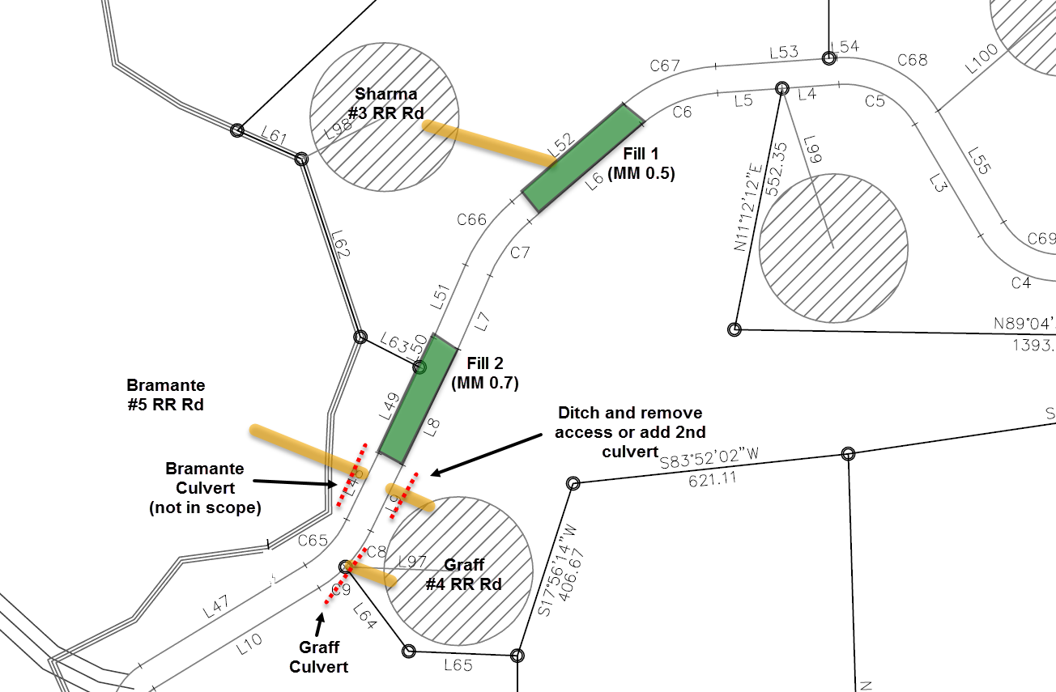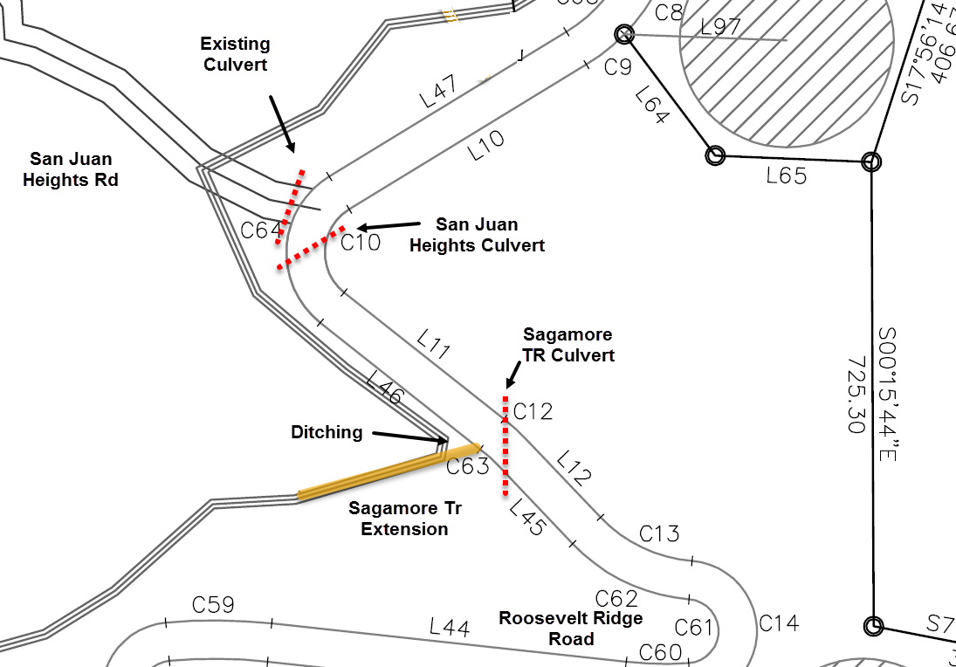

Appendix B - Iron Cross Mine Site
Contractor is responsible for safety at the mine site. Debris, open shafts and other hazards exist. HOA directors will be available to provide additional direction as requested.

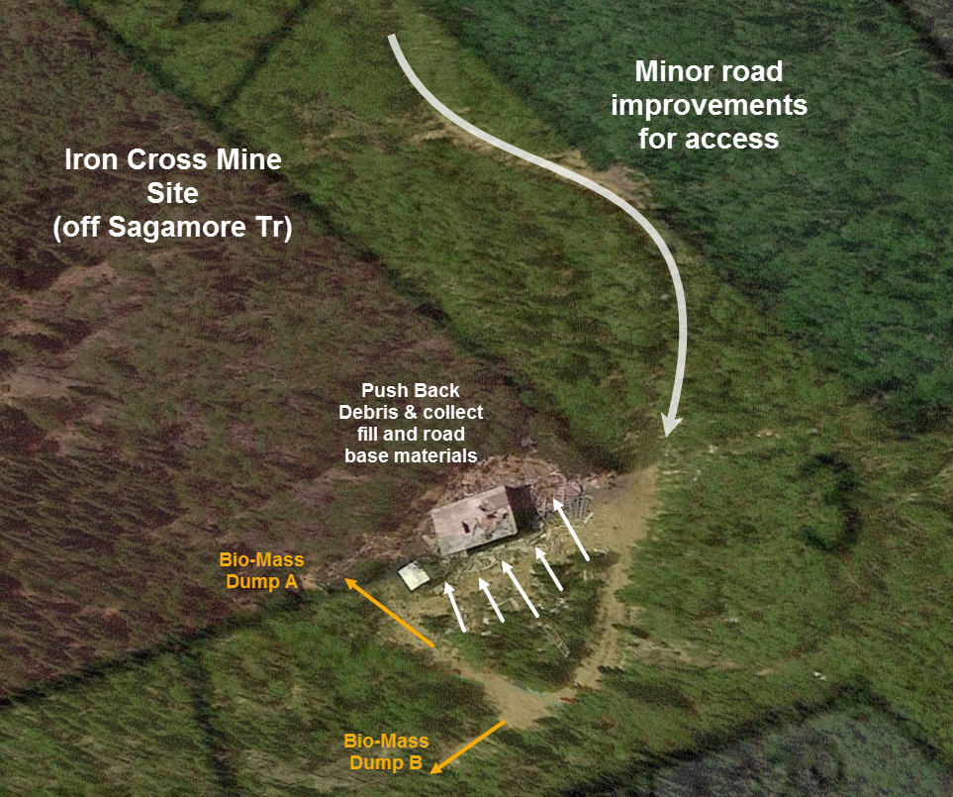

Approval
Name | title | Date | sIGNATURE
 | director, rr HOA

Thank you for your business!

