 | WORK ORDER
Roosevelt Ridge | W.O. # 20210531  Date: May 31, 2021
from | Ted Bertele  HOA Director  303 618 8200  rooseveltridgebod@gmail.com | iNVOICING | Karen Burback  12434 W 85th Ave  Arvada CO 80005  303-929-2229  KABPS@MSN.COM
To | Steve Grapes  Black Diamond Excavating  20 Venus Road  Black Hawk CO 80422  (303) 601-4216  blackdiamondexcavation@gmail.com | Job | Roosevelt Ridge Rd “spring” repair

Terms and Conditions – RR HOA
- Project is T&M with a cap of $3,500
- Provide pictures (text or email) before, during and after repairs
- Target completion date 6/4/21
Terms & Conditions – Black Diamond Excavating
- Per BD standard T&Cs / Proposal
Item Number | DESCRIPTION | Unit | Rate | Qty | Total
 | Emergency Locate
 | Re-routing as necessary
 | Excavate road to isolate water source
 | Install erosion control layers as necessary
 | Install drain to ditch
 | T&M estimate for the above |  |  |  | $3,000
 |  |  |  | Total

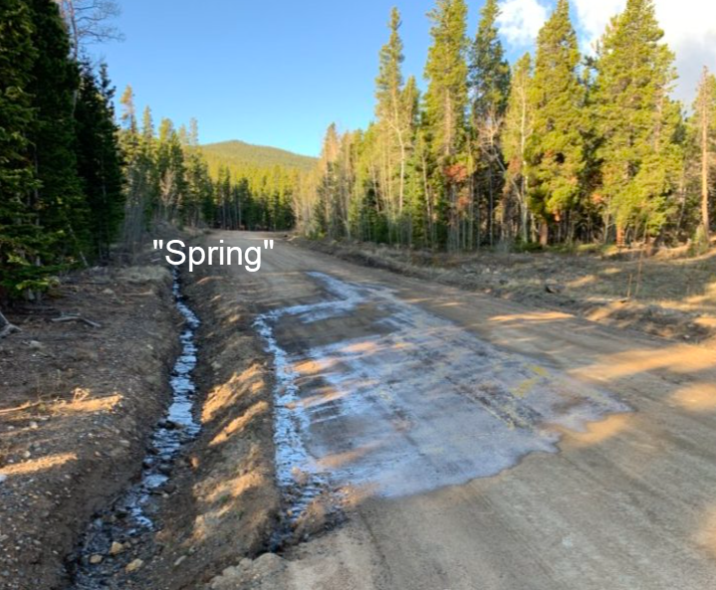

Approval
Name | title | Date | sIGNATURE
Ted Bertele | director, rr HOA | 5/31/21 | Theodore bertele

Thank you for your business!

