References
127419 (9/16/2005) SBE 05-01 Resolution Approving RR Rural Development Exemption Preliminary Plan on 550 Acres in Section 18, T2S, R72W
129088 (2/21/2006) Order for Inclusion of Real Property in the Colorado Sierra Fire Protection District
132632 (2/27/07) SBE 07-01 Resolution Approving RR Subdivision Exemption Filing 2 Creating Lots 18-22
129088 (2/21/2006) Order for Inclusion
Requirements
- That the Owners shall permanently furnish to the fire protection district a site for the construction and maintenance of an apparatus garage at the main entry to the property on Lot 15
- The owners will construct two 30,000 gallon community water cisterns to be used for fire suppression. The first cistern will be constructed prior to the completion of 25% of the homes on the property and the second cistern shall be constructed upon completion of 50% of the homes on the property. The location of the cisterns shall be pre-approved by the Fire Protection District
- Each home site shall include a serviceable 10,000 gallon water cistern with adequate access for fire apparatus
Notes
- Petition was filed by “all owners” of the property and we have copies of signed documentation.
- 7 individuals (Fujji, Feagins, Hobson, Fontaine, Todd, Pure & Kaiser) plus Lone Pine for the remaining lots still owned by the declarant
127419 (9/16/2005) SBE 05-01
Requirements
- Phase one approves 17 parcels
- Phase two shall include a maximum of 10 parcels
- Applicant shall be required to petition for annexation into a tire district and the applicant must complete any code improvements required by the district
Notes
- Maximum number of homes is 27
- Further resolutions passed in 2007 and on permit additional lots to be formed (18-22, 23, 24, 25…)
Trying to figure out when the 25% trigger occurred
Language states completion of a home, an issued certificate of occupancy (COO) seems like a reasonable metric.
Scenario A - 25% of 27 homes is 6.75 homes (max buildout scenario)
- Triggered in 2018 with either the Twining or Bramante COO, not sure who got their certs first
- 2018 is still valid if we only consider the current number of buildable lots (24 versus 27)
Scenario B - 25% of TBD homes available (Phase I) is 4.25
- Triggered in 2016
- Phase 2 was approved in 2007, this is not a triggering event since there was only one completed home during this time.
What’s the point of this exercise?
- To determine ownership pool when the requirement became effective – which is everybody except Burnstein (Lot 25). He purchased his lot after the 2018 trigger.
- Ok, why? Owners are required to make this improvement and that definition could be assigned to a changing pool.
What is the new requirement for RR HOA fire protection?
The BOD had meeting with TFPD (Timberline Fire Protection District) in October of 2019. The fire chief, Paul Ondr adjusted RR’s requirements as follows:
- TFPD does not want a fire equipment apparatus on RR, they have a fire station that is already in proximity. This would negate Inclusion Order requirement 1.
- RR only needs to install one 30,000 Gallon Cistern to meet the ISO standards and will waive the second cistern. This reduces the burdon from the Inclusion Order requirement 2.
- TFPD is not in favor of requiring 10,000 cisterns or sprinklers in homes and will assist RR in removing that requirement. This would negate Inclusion Order requirement 3.
Who should pay?
The BOD have provided multiple estimates on cistern costs. These range from $95K to $135K for a single 30,000 gallon cistern. The estimated assessment per lot is $3,600 - $5,200. Assessment vote is tentatively scheduled for March of 2020. This would likely be done in two phases, an initial contribution to get the dig started and a final contribution to finance the remaining costs to completion.
Members have made claims that the declarant should pay.
SBE 05-01 states:
Applicant shall be required to petition for annexation into a tire district and the applicant must complete any code improvements required by the district

This member asserts that Lone Pine is the “Applicant”. The BOD does not believe this to be a valid argument, however it should be given some due diligence. The BOD believes that the duly executed and recorded Order of Inclusion supersedes SBE 05-01 , and in plain language places the conditions on the “Owners”.
Order of Inclusion states:
Subject to the following conditions.
- That the Owners shall permanently furnish to the fire protection district a site for the construction and maintenance of an apparatus garage at the main entry to the property on Lot 15
- The Owners will construct two 30,000 gallon community water cisterns to be used for fire suppression. The first cistern will be constructed prior to the completion of 25% of the homes on the property and the second cistern shall be constructed upon completion of 50% of the homes on the property. The location of the cisterns shall be pre-approved by the Fire Protection District
- Each home site shall include a serviceable 10,000 gallon water cistern with adequate access for fire apparatus.
The BOD believes there is a credible argument that the original 7 plus the declarant have a shared responsibility.
After Phase 1 was approved, this order was signed and it included 7 individuals (Fujji, Feagins, Hobson, Fontaine, Todd, Pure and Kaiser) plus Lone Pine. The liability for installing a cistern was assumed on each of these owners. Lone Pine should have sold each lot after the order with the assumption that their purchase helps cover funds are paying into a pool to fund a cistern.
Each individual who signed the inclusion order would pay for one share (original 7 shares)
The remaining shares come from the proceeds from the Declarant’s sales of lots (18 shares)
Additional lots that are annexed (Parcel C which is currently for sale) would have to pay into the fund, some reimbursement or distribution adjustment could follow…

The BOD also considers the possibility that all owners are equally liable.
There are no terms and conditions with the sales of these lots that include funding of a cistern. These sales were made “as is”. It’s unreasonable to assume that liability does not go to the new owner.
What about title insurance?
Most owners did not receive this order in their title packet. Failure to disclose this liability by the title company seems like a reasonable avenue to make a claim.
Does it matter if they are in the HOA or not?
I presume not, as the inclusion order refers to owners and not members and property has been defined in other documents at the entire RR per Reception number 127234 (Plat).

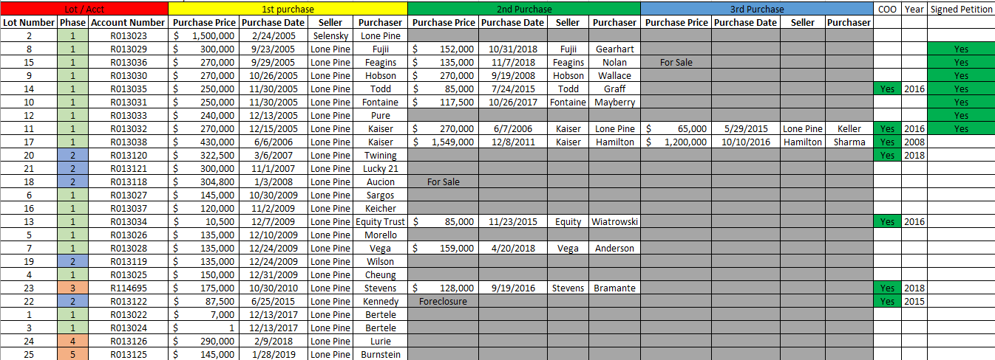
Purchase history of RR Sorted by 1st Purchase Date. This was gathered from public records posted by Gilpin County:

