 | WORK ORDER
Roosevelt Ridge | W.O. # 20180622  Date: June 22, 2018
from | Ted Bertele  HOA Director  Project Manager  303 618 8200  TBERTELE@MSN.COM | iNVOICING | Karen Burback  12434 W 85th Ave  Arvada CO 80005  303-929-2229  KABPS@MSN.COM
To | Steve  Black Diamond Excavating  20 Venus Road  Black Hawk CO 80422  (303) 601-4216  blackdiamondexcavation@gmail.com | Job | Main Road Repair & Enhancements

Terms and Conditions – RR HOA
- Any line item that grows in excess of 10% requires approval from HOA
- Total increase of $1,500 or more requires approval from HOA.
- BD Contract to include schedule
- Weekly reports on progress and schedule updates required (call to Ted)
- Iron Cross Mine Site has several open shafts and other hazardous conditions, Black Diamond to assume all risks in use.
- All construction methods and techniques to adhere to Gilpin County standards whenever practical, exceptions communicated to RR HOA.
- Work start requires 50% down payment ($20,000)
- All change orders require HOA approval and will be issued by the HOA project manager, Ted Bertele
- Sagamore Trail work is pending notification and acceptance by homeowner. Work stoppage (grading and ditching) may be required past Sagamore trail.
Terms & Conditions – Black Diamond Excavating
- Per BD contract

Item Number | DESCRIPTION | Unit | Rate | Qty | Total
1 | Establish access to Iron Cross Mine site (ICMS) for bio-mass dump, fill dirt & road base | Unit | $125 | 4 | $500
2 | HOA procurement of Grizzly Sieve Screens | hrs | $650 | 1 | $650
3 | Equipment Mobilization / Staging Portable Grizzly Screener | each | $250 | 1 | $250
4 | Road Material Excavation & Transport, RR Rd | Tons | $12 | 300 | $3,450
5 | Material Screening for road base + Transport | Tons | $12 | 900 | $10,350
6 | Material Screening for Rip Rap + Transport | Tons |  |  | $500
7 | BD provided Rip Rap |  |  |  | $0
8 | Excavation of RR Rd Shoulders to MM 1.2 | n/a | $125 | 16 | $2,000
9 | Blading & Ditching road to MM 1.2 | hrs | $150 | 20 | $3,000
10 | Ditch Dams & Terracing | hrs | $125 | 16 | $2,000
10a | Terracing Labor, laying rock (HOA provided) | hrs | $50 | 8 | $0
11 | Rock Breaking | hrs | $135 | 10 | $1,350
12 | Front Gate – Haul away stumps, excess RR ties, logs and other debris from front Gate | hrs | $200 | 3.5 | $700
13 | Front Gate – Collect and move boulders to create an effective barrier & level bypass rd | hrs | $200 | 2.75 | $550
14 | Fill in section 1 (MM 0.5 - near Sharma) small section (deferred) |  |  |  | $0
15 | Fill in section 2 (MM 0.7 - near Graff) large section | hrs | $220 | 16 | $3,520
16 | Install Road Base, 1st half mile of RR Road | hrs | $219 | 36 | $7,882
20 | San Juan Heights Culvert | hrs | $760 | 1 | $760
21 | SJH Culvert Install | each | $125 | 9.8 | $1,225
22 | SJH Ditching & Terracing | hrs | $125 | 6.4 | $800
 |  |  |  | Total | $39,487

Line Item Notes:

Item Number | Notes / Requirements
1 | Clean up the access road, clear debris from site; knock down trees at dump points.  Make the work site safer.
2 | Property of RR unless contractor buys it back
3 | Cost from previous proposals  (BD normally charges $1,000+, but jobs on site and scale provided a discount)
4 | Excavating & moving material from ICMS site to RR Rd to fill in the two low spots.  (BD Comment - RR HOA Underestimated fill rqd)
5 | Class 6 Road base material for 1/2 mile (4 in x 18 ft)  <75% of supplier cost ($18/Ton delivered from Frei)
6 | Ditching terracing and dams, RR IC produced
7 | Ditching terracing and dams, BD provides – Possible option.
8 | Pull road material from the sides for the grader
9 | Road width is 22 ft (18ft + 2-2ft shoulders)  HOA to mark preferred centerline (whisker)  Crown with 3% grade with existing or excavated material  Ditch 18 in below road surf (typical)
10 | Ditches will have dams every 50-75 ft where grade exceeds 5%  Rip Rap Terracing as required (BD Notes 100 ft from all culverts)
10a | Roosevelt Ridge Community to install riprap / Terrace
11 | As needed, not to exceed. Rocks not to protrude more than 1 inch
12 | Lee Mayberry will coordinate what needs to go, 1st part of the entrance beautification. Remove all debris, logs and trimmings within 50 ft of gate.
13 | John Kennedy volunteered to do this, but never executed…
14 | Staged material spread and compacted  Road raised approximately 3ft for continuous gradient  Start and stop locations will be marked and verified by HOA
15 | Staged material spread and compacted  Road raised approximately 3ft for continuous gradient  Start and stop locations will be marked and verified by HOA
16 | smoothing, spreading, compaction
20 | San Juan Heights Culvert
21 | San Juan Heights Culvert
22 | San Juan Heights Culvert

Appendix A - Work Map
Approximate locations of the fill areas and culverts. These will be verified and marked prior to execution.
Residents are responsible for driveway access will have the option to provide their own culverts, however they must coordinate with BD who will be doing the ditch work. Residents must ensure proper placement after re-alignment of the ditches and drainage.

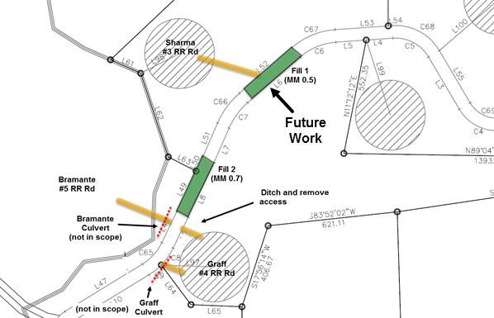
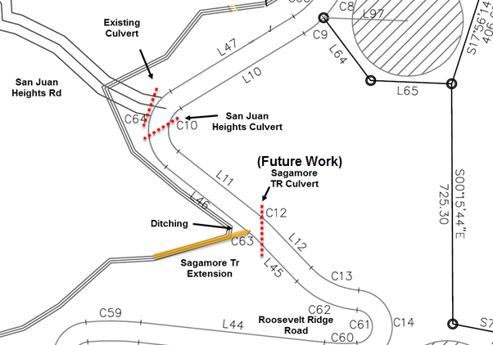

Appendix B - Iron Cross Mine Site
Contractor is responsible for safety at the mine site. Debris, open shafts and other hazards exist. HOA directors will be available to provide additional direction as requested.

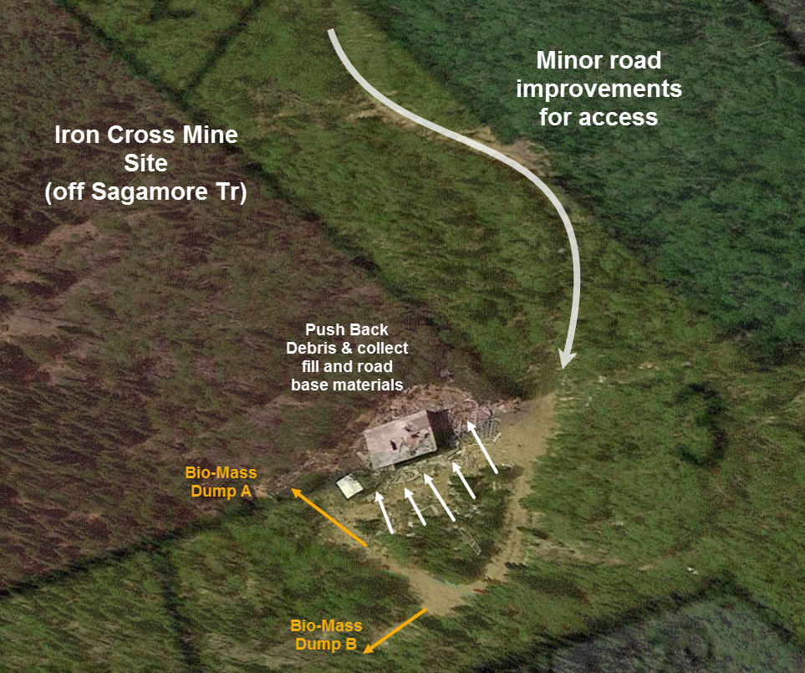

Approval
Name | title | Date | sIGNATURE
 | director, rr HOA

Thank you for your business!

